In January, at the beginning of this semester, the class was presented with a theoretical project that would be using the Scrum Agile project management method to complete. Scrum is an agile approach to developing innovative products and services. It is typically used in software development, however, with its growing success and popularity among project developers, it is making its way into other areas of business. Thus, we were asked to theoretically manage the construction, start-up, and management of a shopping and entertainment center in upstate New York, named Olympus using this method of project management.

Scrum is just one of the many flavors or versions of agile project management. Agile project management is an iterative, adaptive approach that helps ensure that the project delivers what the customer truly needs (Rubin, 2013). It does this through a series of iteration and improvements known as sprints, which provide flexibility and adaptability(Novac, 2018). Our sprints were decidedly one calendar month but depending on the project can be shorter than this. Seeing as Olympus was a large project with construction our sprints were decidedly the longest they could be.

However, before we could begin with our sprints there were roles that we needed to learn first. The Scrum team consists of three important roles, the product owner, ScrumMaster, and the development team. The product owner is the central point of product leadership and has an obligation to make sure that the most valuable work is always performed (Rubin, 2013). They also must keep the stakeholders’ interests in mind while communicating and maintaining a clear vision or goal for the project. The ScrumMaster helps everyone involved to understand and embrace Scrum values, principles, and practices (Rubin, 2013). Also, every organization and even every project create and run their own unique version of Scrum and the ScrumMaster is there to provide process leadership. They also are there to resolve team issues, make improvements to the Scrum, and remove impediments to outside interference that inhibit the development teams’ productivity. The development team consists of a collection of individuals who are responsible for designing, building, and testing the desired product (Rubin, 2013). These members need to be diverse in their skills to be sufficient for the project as well as having T-shaped skills and the ability to self-organize. T-shaped skills mean that they have the ability to work outside of their core area and they have a deep understanding within their functioning area or specialty (James, 2020). These teams are relatively small with up to nine people. For our Olympus project, there was one team, but if there needed to be more teams to get all of the necessary skills to complete the product set forth by the product owner. Also, for Olympus, seeing as we were building a massive building(s), we also needed to hire a construction crew (Boulder Construction Co.).

Next within our Olympus project, we needed to create our Product Backlog and Artifacts. We started with our artifacts which included, a Vision Statement, a Product Roadmap, Press Release, and a 30-second elevator pitch. All of which are important for starting on a massive project and for starting the marketing process. The product owner has a vision of what he wants to create. This can be quite large and no always accurate to what the consumer or customer desires. Thus, the high-level backlog is created and is a list of features that fits with the product owner’s vision. However, a lower level product backlog is created in order to have an achievable task for the development team to achieve. This product backlog is created through user workshops, in which potential customers are offered incentives to come and attend a workshop. In which these users are asked questions and fill out questionnaires as to what they would like to see or have access too. For my version of Olympus for the first workshop, I focused on inviting potential store owners and franchisees who would rent out space in my shopping center, farmers market booth owners, as well as some customers. These were the first group to be invited because they will make the stakeholders the most money the quickest. Afterward, user story cards were created using the information gathered. These stories allow for smaller tasks to be pulled out so that they can be achieved in hopefully one sprint. For our Olympus project, we created 40 user stories along with technical fixes and areas that needed to be researched further. I struggled a little to come up with the 40 user stories, however, in an actual project there would more than likely a couple of hundred user stories, so 40 was very doable without having an actual workshop. Also, the template and teaching by Professor James made it easy to understand.

Once the product backlog was complete we then started our grooming process for the backlog. Grooming is where the backlog tasks or features get prioritized. In our case with Olympus, the priorities were what was going to make stakeholders money the quickest. In my case specifically, this would have been the laser tag arenas in Titan’s Tower (main building of Olympus) and the surrounding shopping complex with the farmers market. Therefore, the construction of those buildings and the requirements or user stories that were gained from the theoretical workshop were prioritized first. In order to show this prioritization, we were tasked with assigning each item on the backlog with a priority status and a story point number. We used the status of High, Medium, and Low, and all of the items are then listed from High priority to Low priority. The story point numbers are from the Fibonacci Sequence and represent the amount of time estimated for that task to be completed. Also, due to the flexibility within the sprints and the ability to change unlike in traditional waterfall methods, if a task is not completed within the estimated time or to the product owner’s approval it can simply be moved into the new sprint until it is done completely. We also determined that our initial velocity or the speed/ number of story points that could be completed in the sprint would be 25. The velocity should not be set at a pace that will cause burn-out within the development team (da Silva, 2016). Once this grooming was complete we were ready to move on to plan our first sprint.

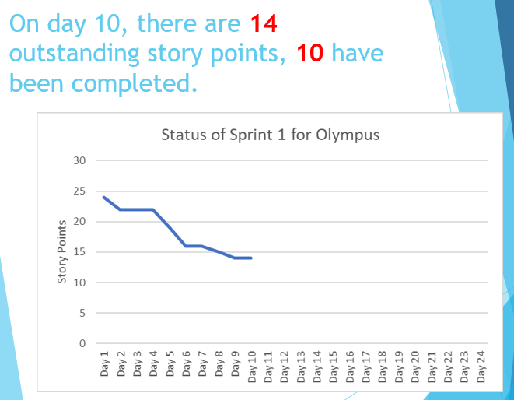Using the spreadsheet that I created with my story points, velocity, and priority levels, I mapped out which tasks were to be complete within the first sprint. Making sure that there were only up to 25 story points being completed. I also then was tasked with estimating and assigning sprints to the rest of the backlog features or user stories. If something were to have come up and gone wrong and the velocity went down to 18 the rest of the plan could be reworked with that velocity due to the flexibility agile provides. The sprints in this project were one calendar month long. That would give us about 20 working 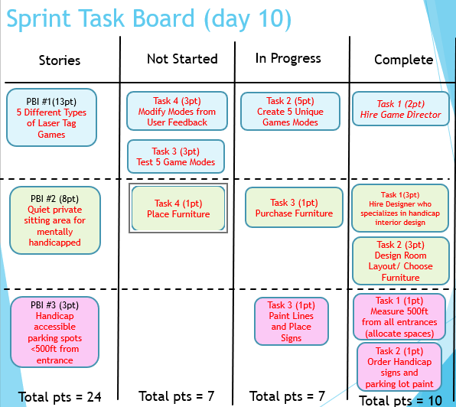days, while the rest is spent in sprint planning, retrospective, and review. Within sprint planning the goal of the sprint is assigned, assignment of items from the groomed backlog, and research occurs. In the class, we went through sprint planning for our first sprint but did not actually go through an entire sprint for the sake of time and also because it is a theoretical project focused on the scrum process. As a part of sprint planning, we created a sprint task board and an associated burndown chart. The task board is a visual aid that helps to show and keep track of the progression of the backlog items throughout the sprint (during execution). Typically, there are three categories, Not Started, In Progress, and Completed. Each task gets put in each category depending on its status at the end of each day. The burndown chart is a visual aid that shows the number of story points that still need to be completed within the sprint at the end of each day. I started on day 1 with 24 story points still needing to be completed then on day 10 the chart shows 10 story points had been completed while 14 still need to be done (see above). These visual aids help to keep things moving and help people who process visual more than simply audibly all throughout the execution of the sprint.

Each day of the sprint, the development team members hold a daily scrum, or a timeboxed 15 minutes or less meeting. This meeting should take place roughly at the same time every day and should take place on-site not in an office building conference room. There also should not be too many people invited. Only those who are fully dedicated to the project (Pigs not Chickens) (Rubin, 2013). This meeting is also held standing in order to help keep the meeting brief. There are typically three questions asked by the ScrumMaster:

* What did I accomplish since the last daily scrum?
* What do I plan to work on by the next daily scrum?
* What are the obstacles or impediments that are preventing me from making progress?

Ultimately the ScrumMaster’s job is to help remove those obstacles and keep the meeting as brief as possible (Rubin, 2013). It also helps for the better self-organization of the teams/ team members, and just a basic status report on the sprint tasks at hand.

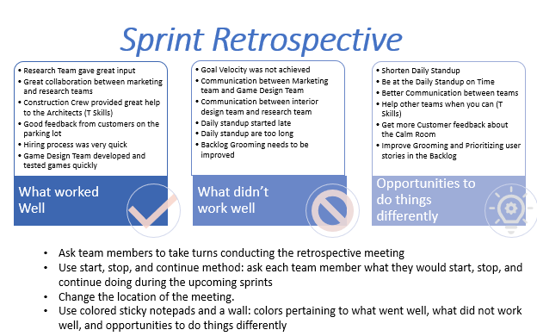Once the sprint has ended the final two inspect-and-adapt activities can occur, the sprint review and the sprint retrospective. The sprint review’s goal is to inspect and adapt the product that is being built (Rubin, 2013). This conversation takes place between the Scrum team, stakeholders, sponsors, customers, and interested members of other teams like the construction crew. Everyone gets clear visibility into what is being created and non-Scrum members get to sync up with the team and guide the development efforts (Rubin, 2013). The sprint retrospective is a time to review and inspect the team’s process. The development team, ScrumMaster, and the product owner come together to discuss was is and what is not working with the technical practices (Rubin, 2013). For my sprint retrospective, I used the categories what worked well, what didn’t work well, and opportunities to do things differently (how the change will happen). There are also a number of ways to keep this meeting interesting and engaging. Once this has been complete you are ready to move on to the next sprint and repeat the sprint processes and execution.

Overall, I did not face any huge challenges or cons in my opinion. The only one that I can think of would be my struggle to assign the story points and how to organize my 40 user stories. I personally just over thought that part of the project. As far as cons in a real-world scenario, even though Scrum and Agile project management seems great there are just instances where you cannot use it, like with project funded by the government. Another con that I think would affect the Scrum methodology is the hiring of the wrong individuals for the development team. If the right people are not hired to work together or cannot get along for any reason then this method would be very difficult and frustrating to execute. However, the greatest pro in my opinion in the flexibility and the ability to adapt not only adaptations to the product but also to the process. It provides an allowance for excellence instead of demanding perfection on the first try. All throughout the process, things can be changed, there is a major chain of feedback and the product is desirable by the customers and not just the product owner, unlike in traditional or waterfall methods. Overall, I feel that I have gained an extensive basis of knowledge and practice with agile project management and Scrum. I thank Professor James for her excellent teaching and her relaxed pace throughout this semester which made my learning and understanding of the course material much deeper than I have experienced in other business courses. I am excited to see how and what I get to apply in my future by using agile project management and even Scrum.

Work Cited

“Chapter 2.” Essential Scrum: a Practical Guide to the Most Popular Agile Process, by Kenneth S. Rubin, Addison-Wesley, 2013, pp. 1–60.

da Silva, Edson Coutinho, and Leandro Alvarez Lovato. "Scrum framework: efficiency in software projects/Framework scrum: eficiencia em projetos de software." Revista de Gestao e Projetos, vol. 7, no. 2, 2016, p. 1+. Gale OneFile: Business, https://link.gale.com/apps/doc/A501246230/ITBC?u=philbibu&sid

=ITBC&xid=c459835c. Accessed 6 May. 2020.

James, Christine. “Development Teams and Managers.” Agile Project Management. Agile Project Management, 25 Mar. 2020, Langhorne, Cairn University.

Novac, Carmen, and Raluca-Silvia Ciochina. "Challenges of Applying Agile Principles and Values to IT Project Management." *Journal of Entrepreneurship, Management and Innovation*, vol. 14, no. 4, 2018, p. 43+. *Gale OneFile: Economics and Theory*, https://link.gale.com/apps/doc/A569457146/PPBE?u=philbibu&sid

=PPBE&xid=a8d88277. Accessed 6 May. 2020.

Wakeel, Fatema El-. "FURTHER DEMYSTIFICATION OF AGILE PROJECT MANAGEMENT: The agile project management methodology has many benefits, but those who've never used it can face some challenges upon implementation." *Strategic Finance*, vol. 100, no. 2, Aug. 2019, p. 76+. *Gale OneFile: Business*, https://link.gale.com/apps/doc/A598536791/ITBC?u=philbibu&sid

=ITBC&xid=b9f4139f. Accessed 5 May 2020.